**G) PROJECT MANAGEMENT**

**G.1) GANNT CHART**

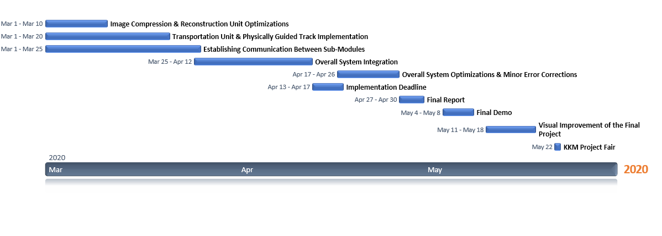

*Figure X: Gannt Chart of the Project Schedule*

**G.2) COST ANALYSIS**

|  |  |
| --- | --- |
| **EXPENSE ITEMS** | **COSTS** |
| Raspberry Pi 3 (To be used in transmitter terminal)  Raspberry Pi Zero (To be used in transmitter terminal) | 205 TL  130 TL |
| Arduino Mega + Vehicle Kit with DC Motor Driver (to implement the vehicle with microcontroller embedded on it ) | 152.5 TL |
| Raspberry Pi 3 Camera Module (to take the photo at the transceiver terminal) | 16 TL |
| 8 x LED (to be used for VLC at the transceiver terminal and on the vehicle) | 1 TL |
| 8 x Visible Light Sensitive Photodiode (to be used for VLC at the receiver terminal and on the vehicle) | 12 TL |
| 3.5`` LCD Screen (to display the reconstructed image at the receiver terminal)  Aluminium Profiles for Physically Guided Track | 50 TL  50 TL |
| Others(Jumpers, breadboard, PCB Plexiglass,Wheels,3D printing costs etc.) | 100 TL |
| **TOTAL COST** | **716.5 TL (117.5 $)** |

**H) DELIVERABLES**

*Equipment*

• Vehicle

The user will be provided with a vehicle which has a transceiver embedded on it. The transceiver unit includes 4 LEDs and 4 photodiodes. The vehicle is able to detect the terminal and accelerate or decelerate accordingly.

• Physically Guided Track

The user will be provided with a 1.5 meters long aluminum constructed rail on which the vehicle can move.

• Transmitting Terminal

The user will be provided with a rectangular prism shaped transmitting terminal which contains a camera, to take a photo, transmitter unit which consists of 4 LEDs and its own computational unit.

• Receiving Terminal

The user will be provided with a rectangular prism shaped receiving terminal which contains a receiver unit consisting 4 photodiodes, a 3.5 inch LCD screen to display the taken photo and its own computational unit.

*Documents*

• Warranty

Revolusys Inc. provides two (2) years warranty in both transportation and communication breakdowns of the system except the user faults.

• Manual

A manual will be provided to the users to get informed about the utilization and the maintenance of the system.